Outgoing EFT (ACH) Manual
Centralized Services

Date modified 14 November 2019

V. 1.1

Version Control
Document Revision History
Date | Author | Version | Description
Nov 14 2019 | Demi Dang | 1.1

Contents
Overview 6
Gathering Reports 6
Input Verification and Edit Reports (IVE Reports) 6
Save IVE Reports 6
Complete the Daily IVE Report Verification 7
Payment Corrections Reports 7
Email Report to ACH Contacts 7
Record Payments Held for Correction 8
Upload IVE reports to FileNet. 9
ALL RECORDS (ALL INPUT, RETURNS AND REVERSALS) Reports 9
Download Reports from RBC Express and Save to Local Drive 9
Payroll (GRADS 074299 IVE Reports) – review for errors 10
NOTICE OF PAYAMENT INFORMATION CHANGE Reports 11
Save Report 11
Upload to FileNet 11
Email Report to ACH Contacts 11
RETURNED ITEMS REPORT 11
Save Report 11
Email Report to ACH Contacts 11
Post in T24 11
Upload to FileNet 12
PAYMENTS ACTIVITY REPORT 12
Take screenshots and paste in the ACH Reconciliation spreadsheet 12
CLIENT VALUE DATA TOTALS Reports 12
Take screenshots and paste in the ACH Reconciliation spreadsheet 12
Payroll Settlement GRADS 074299 12
Importing ACH Database and CS Balancing Database 15
Importing Data to Access Program 15
Import CWB Outgoing EFT Files 15
Import Master Transaction Reporting 16
ACH Reconciliation 17
Enter RBC Settlement Totals 17
Enter Totals Posted in T24 and Exceptions 19
Balancing 21
Manually Deleting Recalled Items 21
Manually Adding Exceptions 22
Posting 22
Posting Exceptions 22
Posting Settlements 23
Email 23
Save 23
Upload to FileNet 23
Recalls 23
Recall Request through ACME 23
Recalling Payments on Payment Correction Reports 23
Recall Procedures 24
Modifications 24
Modification Request through ACME 24
Modifying Payments on Payment Correction Reports 24
Reversal/Error Correction 25
Accounts 27
Section #1 27
Outgoing EFT Recalls Job Aid 27
Process Map 27
Section #2 27
Job Aid 27
Process Map 27
Section #3 27
Job Aid 27
Process Map 27
References 27
Operations Manual 27
Glossary of Terms 28
ACH (Automated Clearing House) 28
Approval Authority 28
Approval Rules 28
GRADS Service Account Number (GSAN) 28
Notification of change ( NOC) 28
Payment Distribution Service (PDS) 28
Pre-Authorized Debits (PADs) Service 28
Appendix #1 RBC Cut-Off Times 28
Appendix #2 Best Practices 28

Overview
Important Information:
There are different GRADS (account) numbers for each type of ACHs:

7420190000 – PAP CAD – CDN WESTERN BK Outgoing Debit Payments for CWB
8370890000 – PDS CAD – CDN WESTERN BK Outgoing Credit Payments for CWB
1074690000 – PAP CAD – CWN WESTERN TR Outgoing Debit Payments for CWT
7307690000 – PDS CAD – CDN WESTERN TR Outgoing Credit Payments for CWT
9004490000 – PAP CAD – ACHDRV Outgoing Debt Payments for Valiant
2489090000 – PDS CAD – ACHCRV Outgoing Credit Payments for Valiant
0742990000 – PDS CAD – CWBPAYROLL Outgoing Credit Payments for CWB Payroll
2802190000 – PDS CAD – NLPAYROLL Outgoing Credit Payments for NL Payroll

For the time being (as of Nov 1, 2018), Banking Support is responsible for CWB, CWT and Valiant settlement and reconciliation. The Payroll GRADs are to be reconciled by HR. Banking Support will only check the Payroll IVE report until HR has been granted access.

Gathering Reports

Input Verification and Edit Reports (IVE Reports)

Save IVE Reports
The IVE reports are downloaded by Computer Operations from an RBC FTP site then saved into Banking Support folders for the day of the week (Tuesday thru Friday – the day the transmission occurs).

Total 6 reports per day.
N:\MISCommon\CAP
*Note: On Wednesday, reports are available in Tuesday folder; On Monday, check Friday, Saturday and Sunday folders.

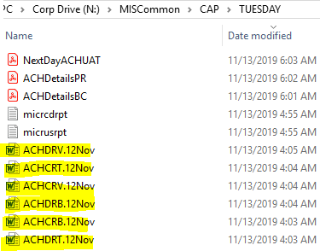

Open each report and run Macro
Save as Word 97-2003 Document to G:\Reconciliations\Outgoing EFT Rec\FlieNet\YYYY

ACHCRB.DATE save as IVE DDMMMYY - CRB 837089
ACHCRT.DATE save as IVE DDMMMYY - CRT 730769
ACHCRV.DATE save as IVE DDMMMYY - CRV 248909
ACHDRB.DATE save as IVE DDMMMYY - DRB 742019
ACHDRT.DATE save as IVE DDMMMYY - DRT 107469
ACHDRV.DATE save as IVE DDMMMYY - DRV 900449

Complete the Daily IVE Report Verification
**See details Daily RBC ACH Excess Verification.docx**
The first page is the Input Verification & Edit Report (IVE report), the second page is the File Input Payment Confirmation report.

- The Input Verification & Edit Report confirms the # of payments and the dollar value of the file received then further categorizes the information into valid & invalid payments & their destination (either RBC accounts or other FI’s).
- The File Input Payment Confirmation report summarizes the ACH file transmission received by due date and further categorizes the payment by valid, & invalid payments

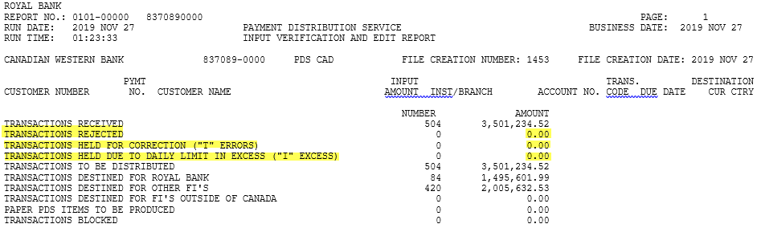

IF TRANSACTIONS HELD DUE TO DAILY LIMIT IN EXCESS (I EXCESS) is not $0, bring to manager’s attention.

Any transactions held for correction (“T” errors) on the IVE report need to be sent to ACH Contacts as Payment Corrections Report.

Payment Corrections Reports

Email Report to ACH Contacts
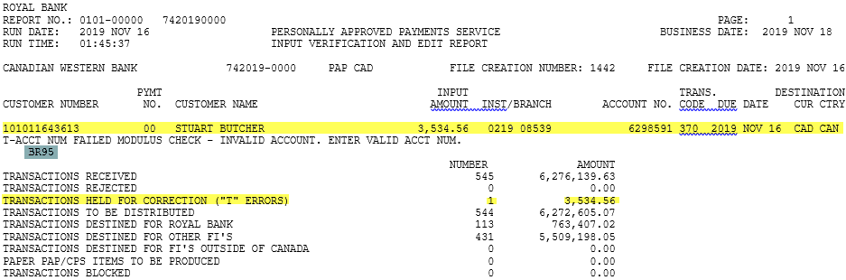
Payments held for correction will show on the first page of the IVE report.
- Find BR # in T24 under Redirection – Account & Branch Search
- Enter the BR # underneath the account # on the report
- Email the report to ACH Contacts
*Note: For CWT Br 96 or Br 01, indicate the appropriate branch in your email
Email templates:
Please email CAP-Deposits@cwbank.com the correct banking information ASAP or by 10am before the due date. If not hearing from you by then, item will be deleted on RBC.
If the due date of the item is prior to the Date of the Report
- Debit file – Email the report to the branch immediately and request branch to provide correct banking info before 10am so that the payment can be modified.
- Credit file – Delete the payment on RBC Express and recall the payment in T24. Email notify the branch that the payment has been deleted from the file.
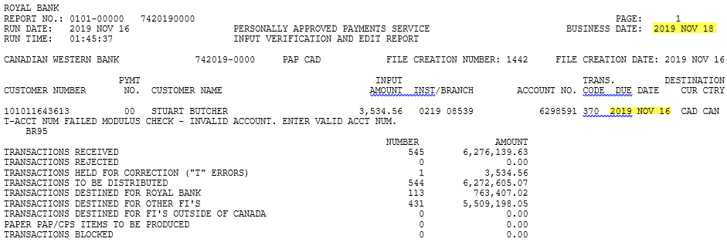

Record Payments Held for Correction
Input payments held for correction on Payment Correction Report.xlsx
Items recorded on the payment correction report spreadsheet needs to be actioned before the due date.
Every morning, check the spreadsheet. If the branch does not provide the correct banking information by 10am the day before due date, Banking Support will delete the item from RBC Express as well as T24 (refer to 3.3 Recall an Outgoing EFT). Banking Support will then notify branch of the deletion.
If the payment is only deleted from RBC Express but not recalled on T24, reconciliation on the due date will not be balanced. The outage equals to the amount of the payment.
The payment posted in T24 on the due date with no issue therefore it was not identified as an exception. In order to balance, we need to manually add the payment on the reconciliation sheet as Posted not Remitted.

If a payment held for correction does not get modified or deleted before the due date, it will not be remitted successfully on the due date. The payment will be captured on the Recap of Payments in Error report.
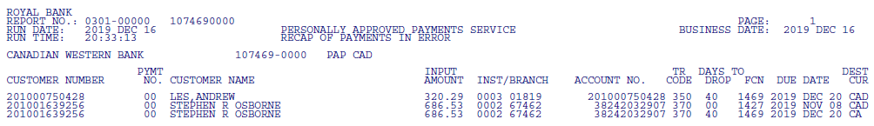

Upload IVE reports to FileNet.

ALL RECORDS (ALL INPUT, RETURNS AND REVERSALS) Reports
NO NEED TO UPLOAD TO FILENET

Download Reports from RBC Express and Save to Local Drive
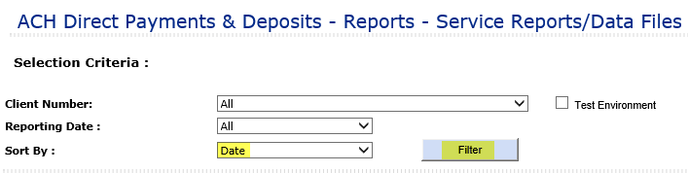
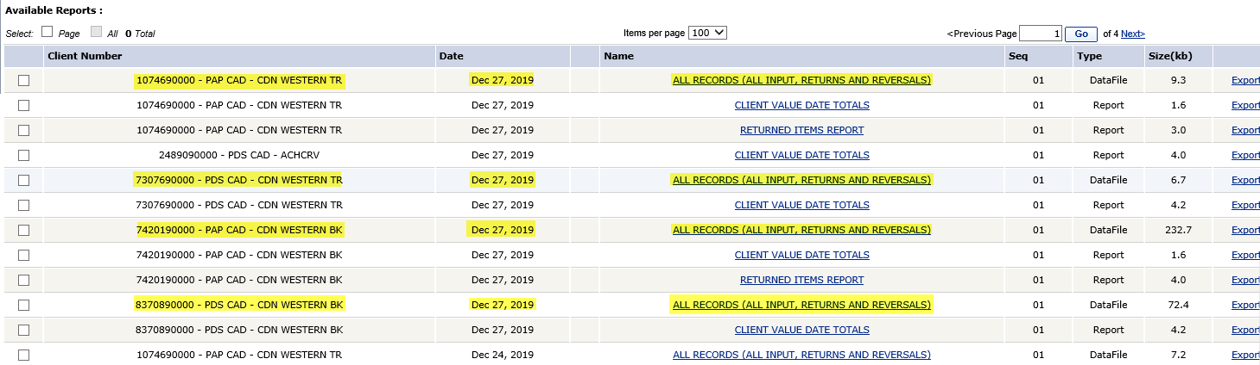
Saving the reports from previous business day.
*Note: On Monday save reports dated previous Friday.
Click Export and from the message bar at the bottom, select Save As
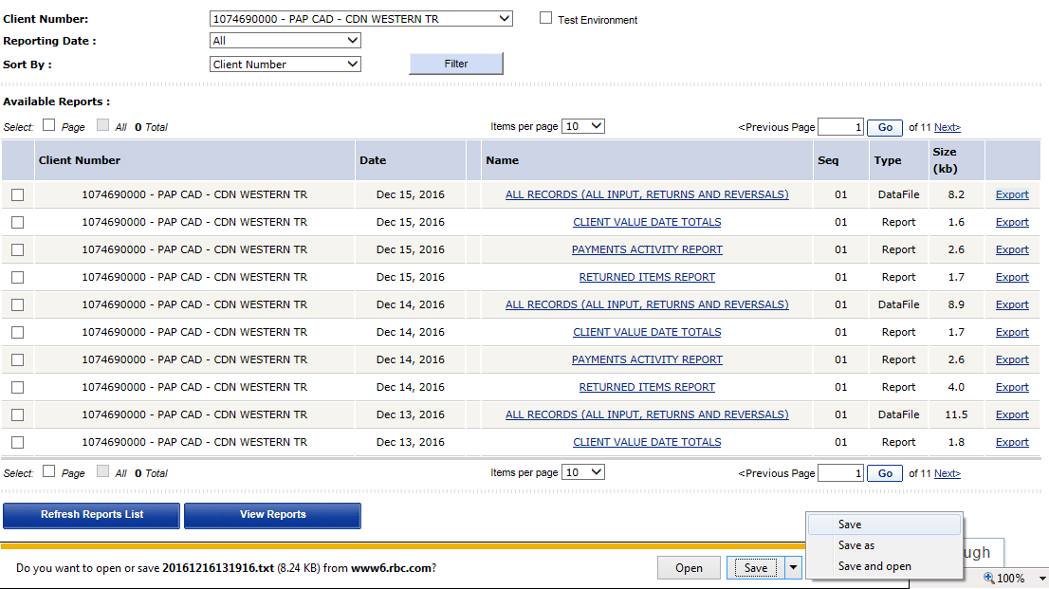
Save as Text Documents (*.txt) to
G:\Reconciliations\Outgoing EFT Rec\RBC All Records Download\RBC Express All Records Download\YYYY:
- 1074690000-PAP save as RBC Express All Records Download 1074690000 YYYY-MM-DD
- 7307690000-PDS save as RBC Express All Records Download 7307690000 YYYY-MM-DD
- 7420190000-PAP save as RBC Express All Records Download 7420190000 YYYY-MM-DD
- 8370890000-PDS save as RBC Express All Records Download 8370890000 YYYY-MM-DD

Payroll (GRADS 074299 IVE Reports) – review for errors
PAYROLL -0742990000
- Client Value Date Totals:
What CAP needs to do is to save these reports as WORD on desktop, then email them to “Payroll and Benefits”, after emailing, delete the report from desktop.
- IVE report:
Save as Word on desktop, email to “Payrolls & Benefits” after emailing, delete the item.
If the error of the item is an “R” error, no correction is required, CAP has to do the following posting:
DR CAD1011000011001
CR CAD1008000011001
R errors will not be processed by RBC therefore need to be transferred to CAD1008000011001
- If the error of the item is a “T” error, HR will update it on the outgoing EFT file.
If the T error is not able to be updated in the outgoing EFT file, Banking Support will complete the following posting:
DR CAD1011000011001
CR CAD1008000011001
Narrative “CWB Payroll Reject”

Until further notice when HR has access to RBC.

Payroll – Stop Payment Request
HR/Payroll team will send the request to CAPManagers@cwbank.com and banking support team will delete the payment from the EFT file on RBC Express.

NOTICE OF PAYAMENT INFORMATION CHANGE Reports

Save Report
Export each report and run Macro
Save as Word 97-2003 Document to G:\Reconciliations\Outgoing EFT Rec\FlieNet\YYYY
- 1074690000-PAP save as Notice of Payment Info Change DDMMMYY -1074690000
- 7307690000-PDS save as Notice of Payment Info Change DDMMMYY -7307690000
- 7420190000-PAP save as Notice of Payment Info Change DDMMMYY -7420190000
- 8370890000-PDS save as Notice of Payment Info Change DDMMMYY -8370890000
Enter the BR # underneath the account # on the report

Upload to FileNet

Email Report to ACH Contacts
Also attach ACH Notice of change .doc

RETURNED ITEMS REPORT

Save Report
Export each report and run Macro
- Find BR # in T24 under Redirection – Account & Branch Search
- Enter in the BR # underneath the account # on the report (for staff account, see STAFF ACCOUNT below)
Save as Word 97-2003 Document to G:\Reconciliations\Outgoing EFT Rec\FlieNet\YYYY
- 1074690000-PAP save as Ret. Items DDMMMYY -1074690000
- 7307690000-PDS save as Ret. Items DDMMMYY -7307690000
- 7420190000-PAP save as Ret. Items DDMMMYY -7420190000
- 8370890000-PDS save as Ret. Items DDMMMYY -8370890000

Email Report to ACH Contacts
*Note: For CWT Br 96 or Br 01, indicate the appropriate branch in your email

Attach below to the email
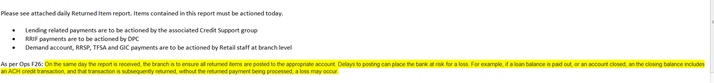

Post in T24
- Returned Debit files (PAP)
ACD6 DR CAD101100001X001
CR CAD1013800011001
- Returned Credit files (PDS)
ACD5 DR CAD1013800011001
CR CAD101100001X001

Upload to FileNet
STAFF ACCOUNT
If a staff account is on the Returned Items Report, create an individual report (black out all other branches), and send it only to Staff Lending (Sherri D), CAP Loans (Lucia B) and the Bank Rec group (Eresha and Maureen) then reverse the item from the account if it’s from a demand acct. If it’s a loan, leave it for CAP Loans to handle.

PAYMENTS ACTIVITY REPORT
When recalls or modifications have been completed on RBC Express, the payments will show up on the following day’s Activity Reports.

Recalled payment will show as DEL
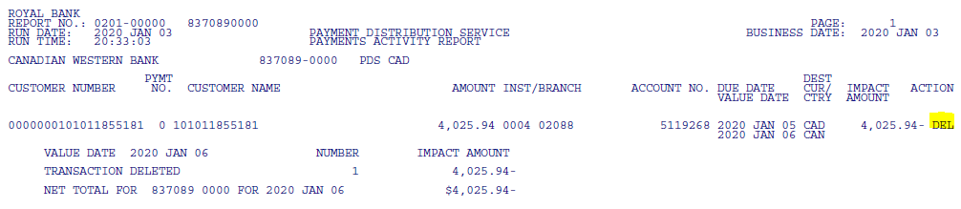

Modified payment will show as COR

Take screenshots and paste in the ACH Reconciliation spreadsheet
Used for ACH reconciliation

CLIENT VALUE DATA TOTALS Reports

Take screenshots and paste in the ACH Reconciliation spreadsheet
Used for ACH reconciliation

Payroll Settlement GRADS 074299
Generated 4 days prior to payday
Post in T24 on payday
AC DR CAD1011000011001
CR CAD1013800011001
Remarks/Comments: PAYROLL GRADS074299 MMM DD YYYY
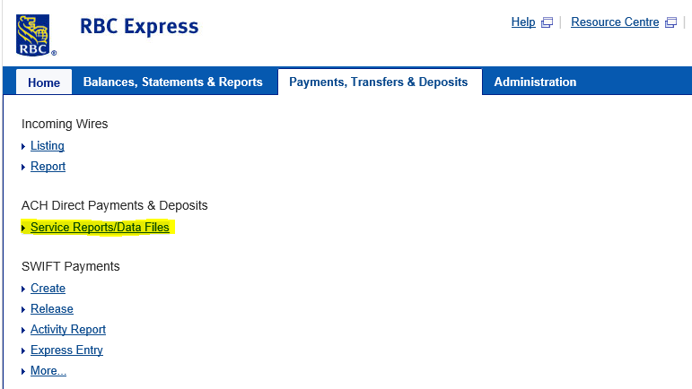
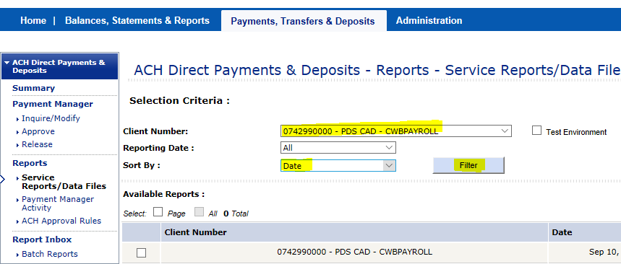

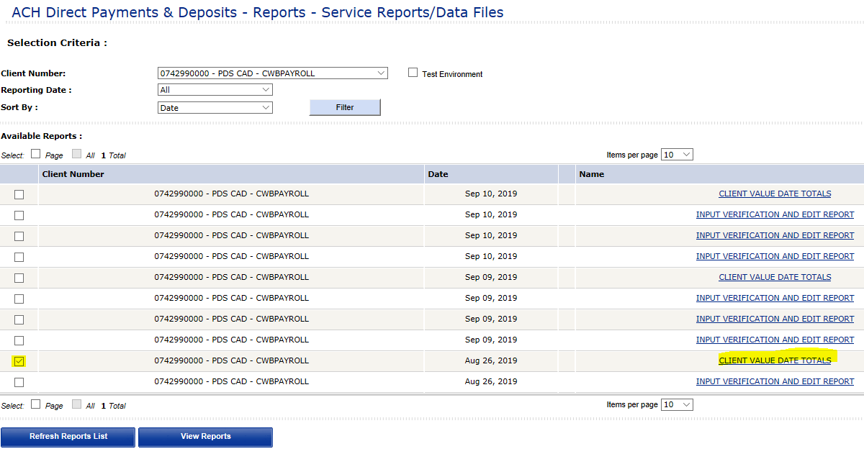

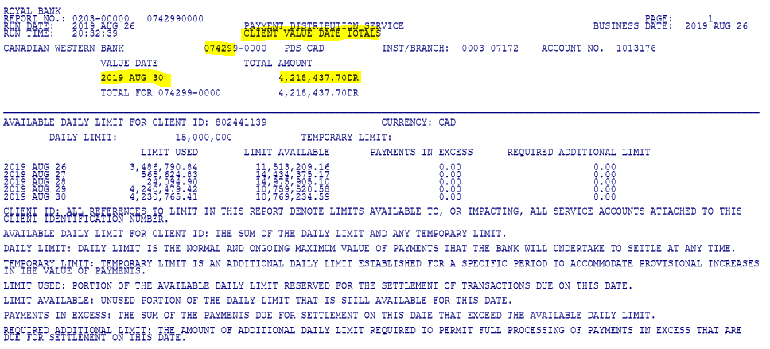

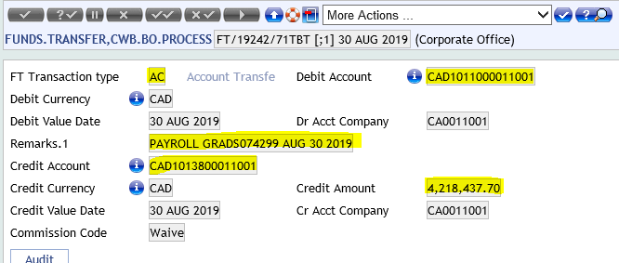

Importing ACH Database and CS Balancing Database

Importing Data to Access Program
NOTE: Master Transaction report is imported into CSBalancing Database before ACH Access Rec can be updated. This is done by a Reconciliations Officer first thing in the morning. An email will be sent out to let the team know the database has been updated.

Import CWB Outgoing EFT Files
Open the Access program from G:\Reconciliations\Outgoing EFT Rec and double click Import_ACH_TextFiles:

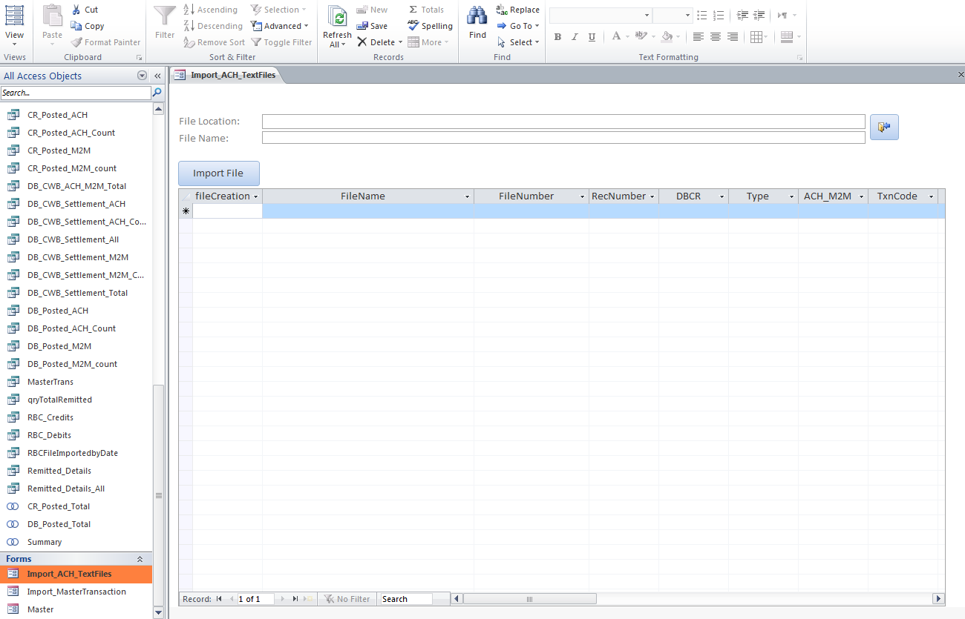
Click the import button on the right and navigate to G:\ACH\ACH Reconciliation\CWB Outgoing EFT Files.
Import each of the 6 files into the program by double clicking the file and then clicking the Import File button. After a weekend, repeat the process for each date.
Navigate to G:\ACH\ACH Reconciliation\CWB Outgoing EFT Files and archive the imported files by creating a folder titled YYYYMMDD. Move the files into the new folder and then move that folder into Imported Files.

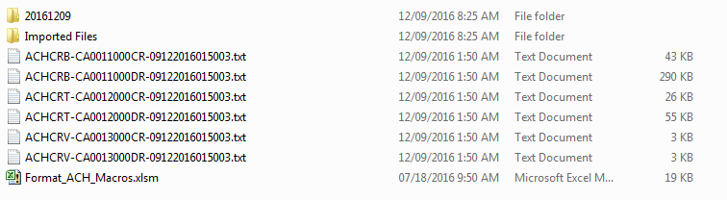

Import Master Transaction Reporting
Double click Import_MasterTransaction:
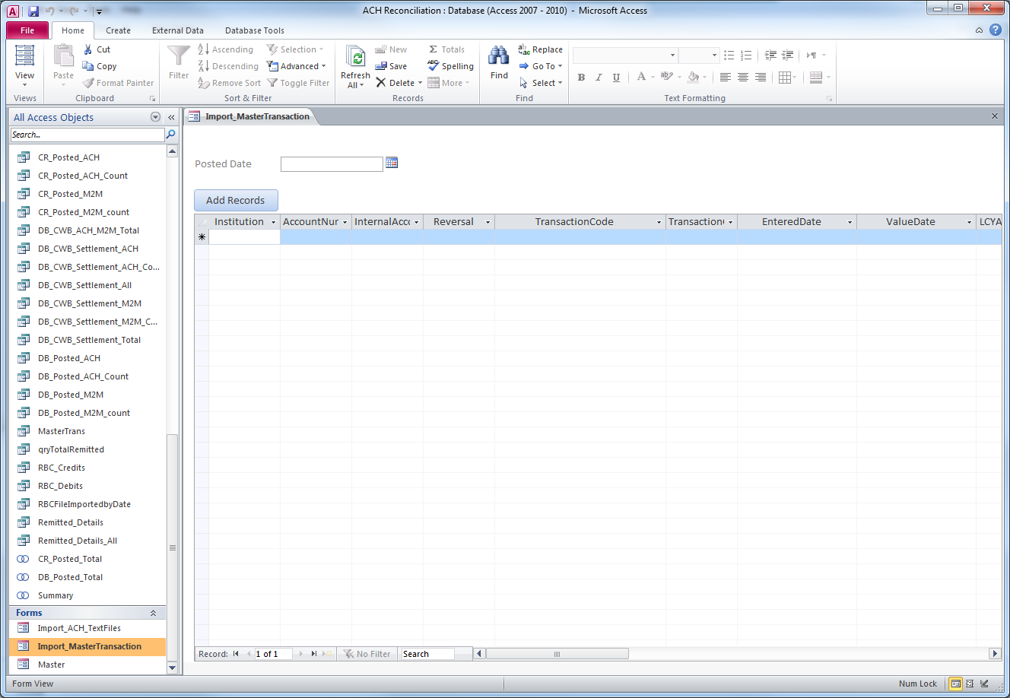
Select the date from the calendar button and Add Records. After a weekend, this will be done for each day separately.

ACH Reconciliation

Enter RBC Settlement Totals
Open master balancing spreadsheets from G:\Reconciliations\Outgoing EFT Rec
- Outgoing EFT Settlement Balancing_CWB
- Outgoing EFT Settlement Balancing_CWT
- Outgoing EFT Settlement Balancing_VTC
Clear all contents entered from previous day.
Use the Client Value Date report (screenshots pasted in the balancing sheet) to enter the previous day’s RBC settlement total next to the heading “PAP/PDS Settlement GRADS ____” for each GRADs account.
*Note: on Monday pull report dated on Friday and on Tuesday pull report dated on Monday (contains Saturday, Sunday and Monday). Exceptions: Family Day (3rd Monday of February) and Heritage Day (1st Monday of August) are not Federal statutory holidays. Coming back to work on Tuesday you need to balance Friday and Saturday-Monday separately.

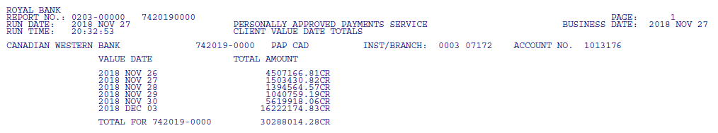
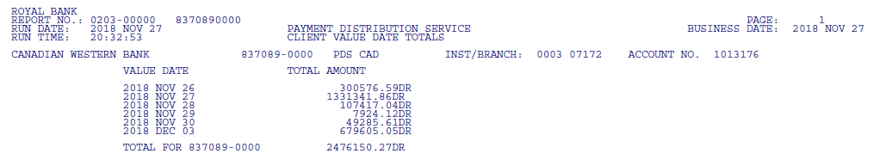
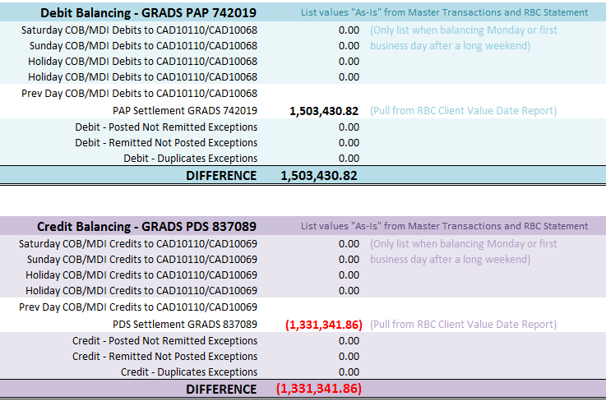

Enter Totals Posted in T24 and Exceptions
Open the Access program and double click the Master heading, located at the far bottom left corner.
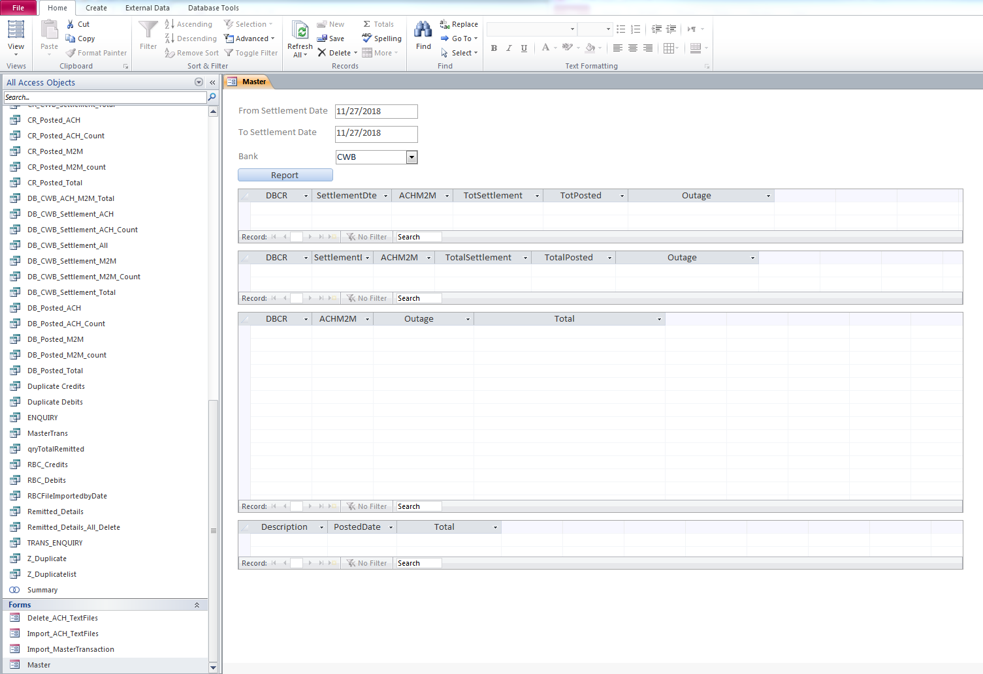
Enter the date and chose CWB, CWT or VTC and then click Report:
*Note: when balancing Saturday/Sunday/Monday on Tuesday, you will need to run the report for each day individually.
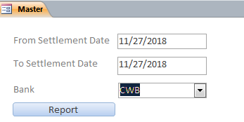
The Report function will compare the ProductBalancing (transactions posted to CAD10110, CAD10068, CAD10069) to the Outgoing EFT Files and will create a tab for each exception type:
- 1_DB_CWB_ACH_PostedNotRemitted
- 1_CR_CWB_ACH_PostedNotRemitted
- 1_DB_CWB_ACH_RemittedNotPosted
- 1_CR_CWB_ACH_RemittedNotPosted
- 1_DB_CWB_ACH_Duplicates
- 1_CR_CWB_ACH_Duplicates

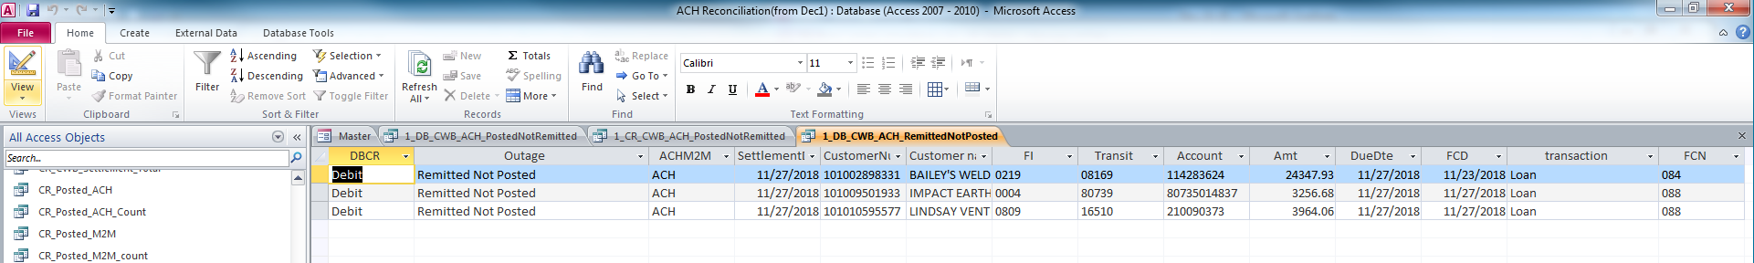

Copy any results from these tabs to the balancing spreadsheet - Exceptions tab and close the tabs as you go.

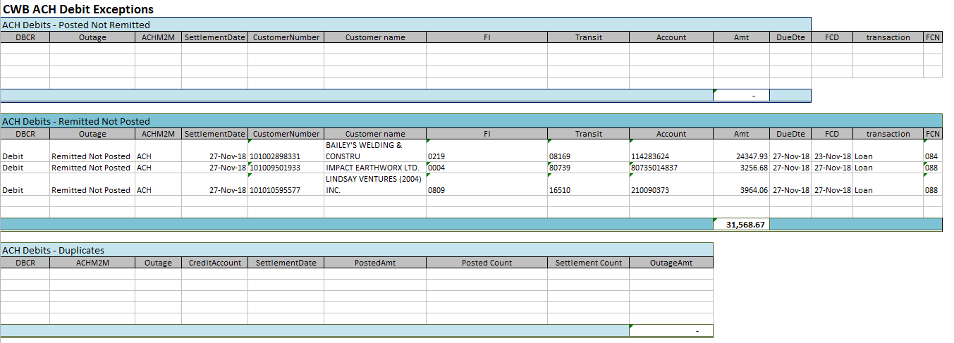

Once all exceptions tabs are closed, the Master tab will now show the TotalPosted amounts (1 day back postings to CAD10110 – ACH transactions, 2 day back postings to CAD10068 and CAD10069 – Me2Me transactions) as well as a summary of the exceptions.

Take screenshots of the Master tab and paste in the balancing sheet.

Take the TotalPosted amounts and enter them into the balancing spreadsheet under Prev Day Debits and Prev Day Credits.

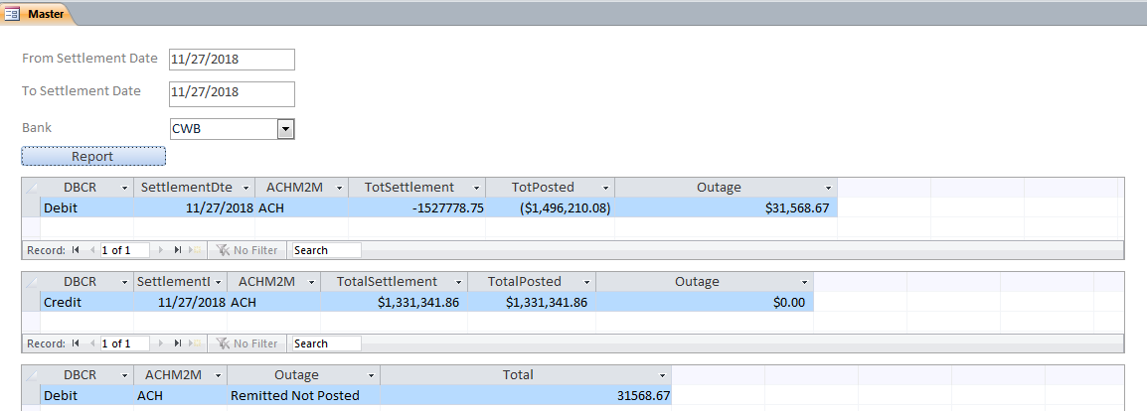

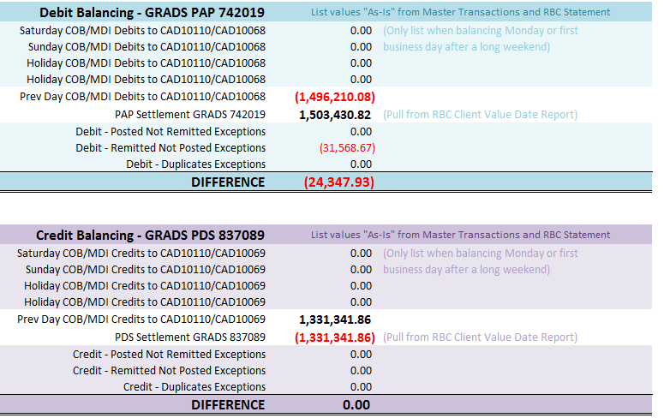

Balancing

Manually Deleting Recalled Items
The ACH reconciliation may not be balanced due to recalled items listed as exceptions.
Since the Access program compares T24 postings to the CWB Outgoing EFT File rather than the RBC Settlement file, recalls will need to be manually removed from the exceptions in order to balance.
Recalls are captured on the Payments Activity Report (screenshots are pasted in the balancing sheet for reconciliation).
Pull all the Payment Activity reports containing recalls for the date you are balancing. Delete these recalled payments from the exceptions.
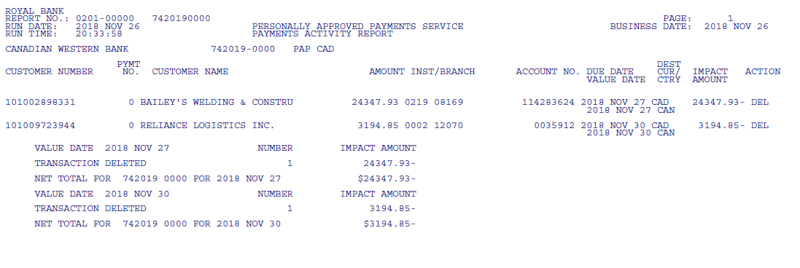
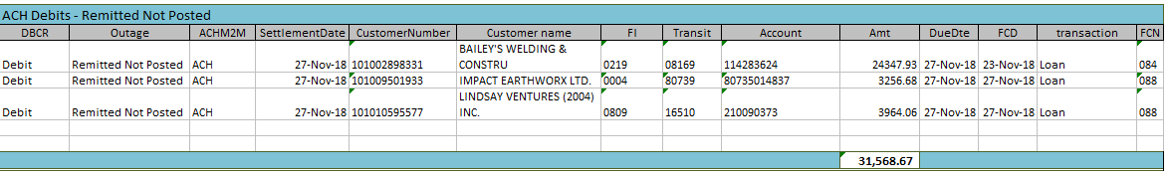
Delete

Manually Adding Exceptions
Refer to Payment Corrections Report.

Posting

Posting Exceptions
For each exception, look up each account number in T24 to locate the home branch number. Add the branch number and internal suspense account (CAD17255 for loans, CAD10998 for all other) next to the exception.
Post each exception to the indicated branch suspense. *Except: Me2Me transactions showing a balanced debit and credit and have the same CIF number do not need to be posted.*
Effective Date (Value Date): due date of the payment Note: over month end post as of 1st of the month
Payment Details: ACH EXCEPTION account number (as shown on the report)
DEBIT – POSTED NOT REMITTED – AC DR branch suspense account CR CAD10110
CREDIT – POSTED NOT REMITTED – AC DR CAD10110 CR branch suspense account
DEBIT – REMITTED NOT POSTED – AC DR CAD10110 CR branch suspense account
CREDIT – REMITTED NOT POSTED – AC DR branch suspense account CR CAD10110
DEBIT – DUPLICATE (Posted x1, Settled x2) – AC DR CAD10110 CR branch suspense account
DEBIT – DUPLICATE (Posted x2, Settled x1) – AC DR branch suspense account CR CAD10110
CREDIT – DUPLICATE (Posted x1, Settled x2) – AC DR branch suspense account CR CAD10110
CREDIT – DUPLICATE (Posted x2, Settled x1) – AC DR CAD10110 CR branch suspense account

For CWT BR96 Loan, post a DR/CR to CAD1725500012096 and DR/CR to CAD1011000012001
For CWT BR01 (not loan), post a DR/CR to CAD1099800012001 and DR/CR to CAD1011000012001
For Valiant Trust, post a DR/CR to CAD1099800013001 and DR/CR to CAD1011000013001

Posting Settlements
Email
No need to send the entire worksheet. Email only the exceptions to ACH Contacts.

Staff account exceptions are sent separately. Refer to Staff Account section.

CWB loan/mortgage exceptions are handled by Credit Support
RRIF exceptions are handled by Banking Support DPC
RRSP and TFSA exceptions are handled by branches

Save
Once complete enter e-signature and save to G:\Reconciliations\Outgoing EFT Rec\Daily ACH Settlement Balancing\YYYY

Upload to FileNet

Recalls

Recall Request through ACME
Most common request is branch requesting a recall of a Loan Payment if they do not want the payment to go through the client’s account.

When a payment is in Process status, it is eligible for recall.
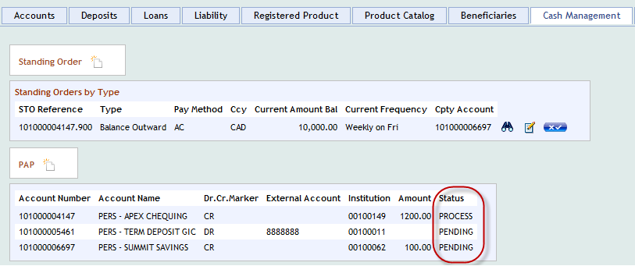

Recalling Payments on Payment Correction Reports
Payments will be deleted if correct banking information is not provided by the cut-off time before due date.
Once the recall is complete, update the Payment Correction Report tracking sheet.

Recall Procedures
Details see attached Outgoing EFT Recalls Job Aid
Banking Support Officer is the 1st approver. Then the payment will be approved and released by another Banking Support Officer. If the amount is over $25,000.00 a Banking Support Manager is required to approve and release.
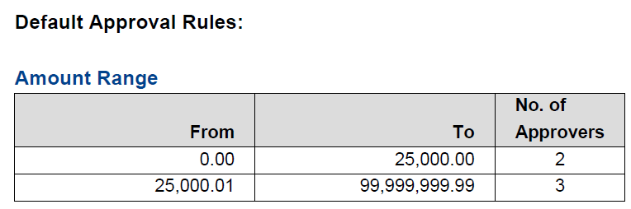

Modifications

Modification Request through ACME
When a payment is in Pending status, it is eligible for modification.

Modifying Payments on Payment Correction Reports
If branch is able to provide the correct banking information prior to due date, Banking Support Officers will modify the Outgoing EFT record in RBC Express.

Once the modification is complete, update the Payment Correction Report tracking sheet.
Payments held for correction only need to be modified in RBC Express.
If the branch also modifies in T24, it will cause a duplicate file created and sent out on the due date.
If the modified payment does not go through, it will be listed under “Deferred”.
Contact the branch and obtain the correct banking information. Otherwise delete it before due date.
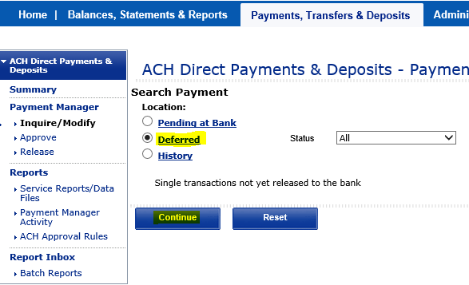

Reversal/Error Correction
After the due date, a reversal/error correction is required for any file sent out in error.

It is not recommended

Post AC DR CAD10138
CR CAD10110

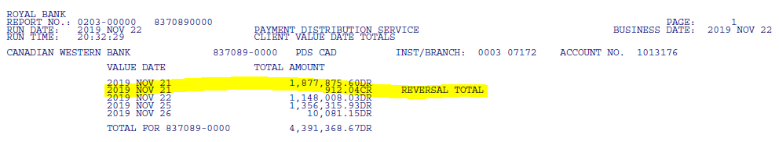
If a branch needs to request a reversal of an item after the due date, they should send CAP BC an email, indicating:
Name of customer
Account number
Due date
Amount
Note: RBC only accept this type of request 4 business days after delivery of the original credit or debit transaction.
CAP then Login RBC Express as above,
Print the “Details” of the payment
Fill up the “Reversal / Delete Payment Request” – signed on it
Fill up a Fax Cover Page
Fax all 3 pages to RBC Fax# 1 800 882 0055
The next date, this item will show up on the Payment Activity Report as “RVA”.

Branch can also request a reversal of a regular loan that has already processed to the Loan from RBC as long as within the recourse period. However, branch has to provide a reason of return. CAP will process as above, except no posting is required.

**same day 11:00 am pending history

Accounts
Account Number | Bank | Description | Details
7420190000 | CWB | Debit another institution
8370890000 | CWB | Credit another institution
1074690000 | CWT | Debit another institution
7307690000 | CWT | Credit another institution
9004490000 | VTC | Debit another institution
2489090000 | VTC | Credit another institution

Section #1

Outgoing EFT Recalls Job Aid
Outgoing EFT Recalls JOB AID.docx

Process Map

Section #2

Job Aid

Process Map

Section #3

Job Aid

Process Map

References

Operations Manual

Glossary of Terms

ACH (Automated Clearing House)
ACH term used to describe electronic payments. Also referred to as Direct Deposits, Direct Payments, and Pre-Authorized Debits.

Approval Authority
A specific limit set up for approvers within your organization to release direct payments and deposits for processing.

Approval Rules
These are rules set by your organization, and define the number of approvers needed to authorize payments and deposits within specified dollar amount ranges.

GRADS Service Account Number (GSAN)
The Global Receivables & Disbursements Service Account Number (GRADS) uniquely identifies you within this system, by service. This 10 digit number is also referred to as the client Account Number and Company ID (described above) or GSAN number.

Notification of change ( NOC)
Notification of payment information change (NOC) received from financial institutions in Canada with regard to bank, branch and account number that occurs as a result of branch closures, mergers or acquisitions. NOC applies to both Canadian and US dollars accounts.

Payment Distribution Service (PDS)
Payment Distribution Service refers to ACH Direct Deposit Service.

Pre-Authorized Debits (PADs) Service
Pre-Authorized Debits (PADs) Service refers to ACH Direct Payments Service.

Appendix #1 RBC Cut-Off Times
RBC ACH Help Centre - Bank Holiday Schedule

Appendix #2 Best Practices

